
TeLeTOP, Or A Learning Organization Revised

Ger Tielemans, Senior Consultant ICT,
Dinkel Institute, Twente University, The Netherlands
g.j.tielemans@dinkel.utwente.nl

The most valuable part of your organization is the knowledge your best men and woman build up in their heads, just before they leave your organization for a better salary elsewhere or for another human reason.
Wouldn't it be nice to let them share their growing knowledge with their colleagues, just in case that… O, you worry about that already for years? Yes, I know: the old problem is that your best people are running your business and don't have time to spend hours on teaching their younger colleagues.
And yes, if you would hire a training company - like your colleague maybe did in that IT pilot project - then you see that the same people would even loose more time in their project role as "explaining domain expert" in all these course design meetings with that company.

From a more practical point of view: you will never find the money ( x times the pilot budget) you would need to design courses for all these valuable disciplines in all your departments: For functions that are more general and spread out over your organization it can be even more cost-effective to buy
a general course on the market. But we are now talking about very specialized higher skills, that only few people in your organization have and only relatively few others need.

Now you can choose for another solution for your brain drain problem by using the advantages of the WWW: Suppose that your best working staff members could stay at home now and then and suppose also that they - on the fly, sitting in their favorite chair at home - could design and deliver a course about their expertise to their colleagues. If this sounds good to you, then start thinking about the best bonus you would give your staff members to get involved, in the meantime I will sketch more details of this WWW-solution.

Design constrains:
Starting with these valuable experts in the higher skills domains in mind, we at Twente University in The Netherlands created a course-design & deliver system for the modern Internet, on top of the robust IBM/Lotus Domino web database and we called it TeLeTOP: TeleLearning on TOP level.

- We knew, that it should not become a very complicated system, because these experts don't have time to read a fat manual or attend a long instruction meeting about using that system.
- As I said before: the tools we had to design, must be also available in their living rooms, so we decided to design for the standard web browsers most people already have at home.
- The kernel learning activity for this kind of courses is the creating and sharing of papers, combined with a good communication infrastructure: So we took a groupware product as a starting point.
- We admit - and more companies do so nowadays - that "Live" classes were and will always stay the best learning environment for these higher skills, so we call our WWW-approach second best.
- A combination of the good old "Live" classes & WWW-support may even be a better choice:
We believe in this hybrid approach, the best of both worlds, and we call this combination concept: C@mpus+
- For security we lean on a Domino Web Server with RSA Data Security from IBM/Lotus, which gives us the possibility to differentiate in the access rights on the system. (None, depositor, reader, author, editor, designer or system manager.)

Now think a moment not about computers and the WWW - not that easy nowadays - but try it.
How would you then design a course about a subject you are feeling comfortable with?

- First you would select some topics you want to give special attention in your course.
- Then you take your paper notebook and - for each topic separate - you write down on a blank page a title for that topic and add a short description.
- The next thing you do is think about an assignment that could accompany this topic
- Again you write down a text, this time for the assignment.
- While creating the text for this assignment, you realize that a student in "your" course would need extra resources as study material to fulfill that assignment, so you make a note of that at the bottom line of your paper and collect the resources on floppies in… let's say a "resources" box.
- After finishing your topic, you could say that working this way you wrote down a very small learning module for that topic, lets call it therefore a learning molecule or in a more schematic representation:

Help resource
Weblink
Video
Text
Topic Title
+
Description
Assignment
Description
Molecule Learning Topic (MLT)

- The next step in your design is that you think about extra learning activities before and after this assignment: For example, shouldn't it be nice to start with an orientation task before and a kind of reflection task after the topic/assignment combination you just wrote down.
- Again you create - in the same procedural way - two extra learning molecules:
3 Molecules
Orientation Maintask Reflection

- As a reminder for yourself - to keep these three molecules together - you could draw a box around them:
3 Molecules in a box…
Orientation Maintask Reflection

- For the other topics of your course you create also these "three molecules in a box" descriptions.
- Put together these boxes as rows in a timetable and you end up with your first draft for a course:
Orientation > Maintask > Reflection
Time...

- Of course you will rethink several times your first draft and reshuffle the time order of the topic rows, so it must also be possible to promote or demote these rows during the design process…

What we did in TeLeTOP is mimic these twelve steps of this "natural teacher behavior" in a real web environment. Does it surprise you that even professors at our University love it?
Now let's visit our demo website in The Netherlands, so open a normal web browser and type the URL:

http://education2.edte.utwente.nl/TestTeletop.nsf

You have to fill in a UserName: docent.test and a PassWord: docent.test
You will then arrive at the news page for this demo course. Read the last news and then click on the button Roster on the left: Because you have teacher (=editor) rights in this course, you can open each roster row by clicking on the small writing hand, for example the one of the first row:
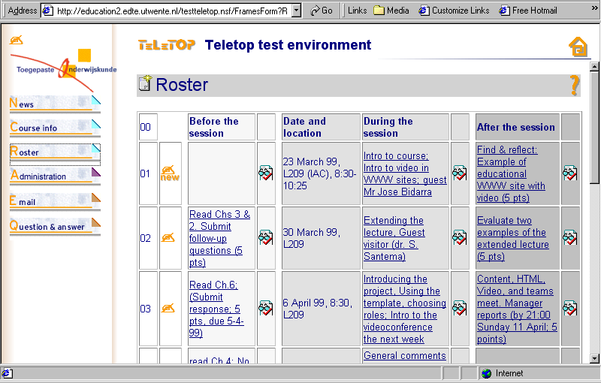

This row then will open in edit view: Type a new topic (Name: NEW) in the first empty cell of the row:
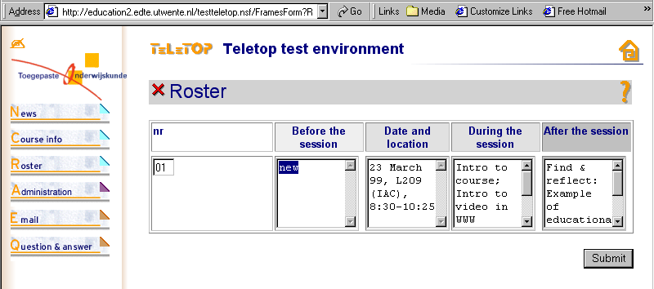
Then send this change back to our server in The Netherlands by pushing on the button Submit.
(By changing the row number you can even promote or demote the row in the scheme.)
The Roster scheme will then be updated on the server and show up again with a new hyperlink on the place where you did type the topic name new:

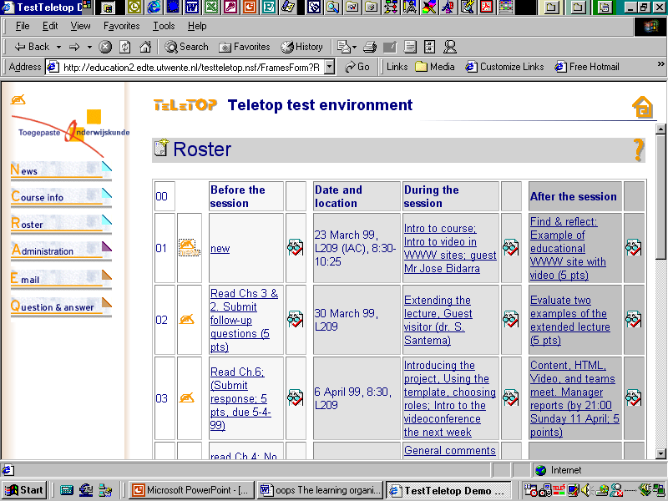

Now click on this hyperlink new and a new web page behind this hyperlink will open up
(See this after next page.)

- If you visit - like here - a (web) page of a TeLeTOP course with teacher login rights, the page always opens up first in the student view.
- Pushing the extra buttons - you only will see in teacher view - will open the form view .
- Teachers like this switch mechanism between the student presentation view and the teacher creation view of every page. Especially if it is the first time they create courses on the web, it helps them to feel more comfortable and secure about their new teaching endeavor.
- By clicking on the small writing hand you can switch to the teacher view on this page, but lets first make a small sidestep by taking a closer look at the student view of this page.
OK, as I said, first a look at the student view on this (demo) assignment page:

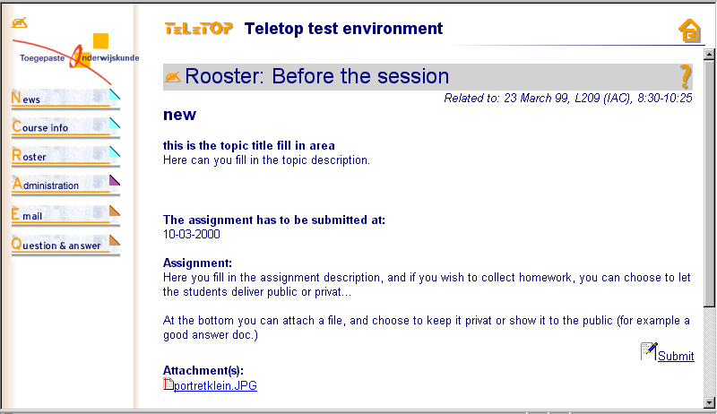

If the student presses the Submit button, the form opens up as a homework delivery fill in form: Normally his name is on the form, now it says docent.test because that is the name I did use to log in.

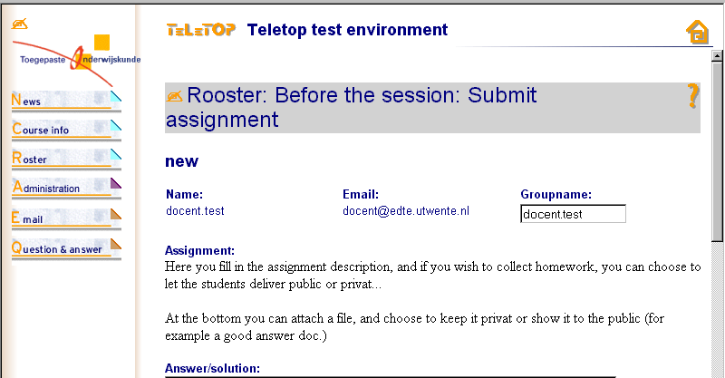
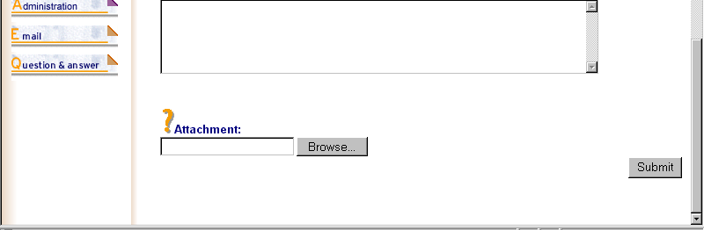

Students can fill in the answer box and/or attach an answer file, for example a prepared text in Word.
(Any MIME type can be exchanged this way between teachers and students.)
Now back to the teacher view: After pressing the writing hand, the page opens up. If you look closer at this teacher fill in form, than you see that it prompts you to fill in component boxes for each topic.
Do you recognize the parts of the earlier learning molecule? Topic Title & Description, Assignment Description (with as extra: radio button choices to let you choose the way you want your students to deliver their homework for this topic: public, privat or not.), and at the bottom the extra Resources.
(Sorry for the mix of Dutch and English in this old prototype form)
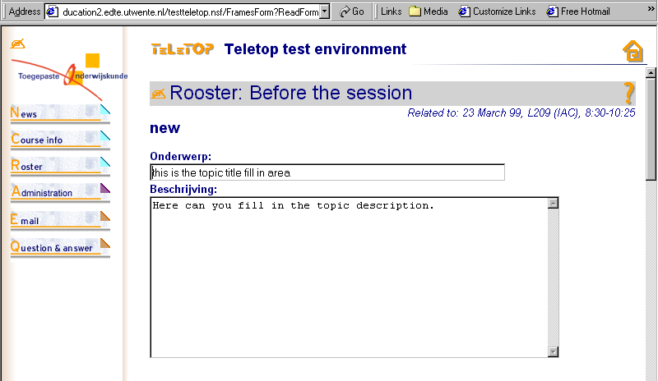
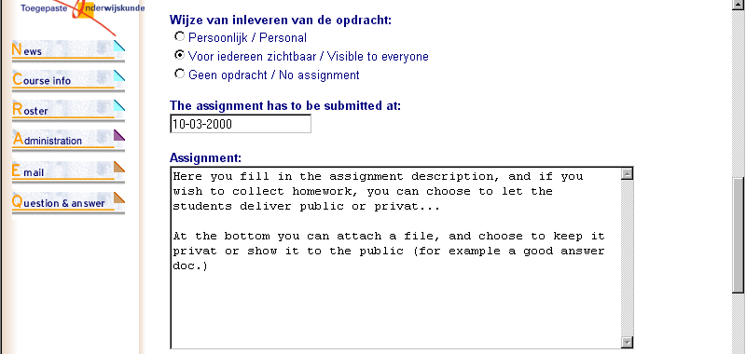
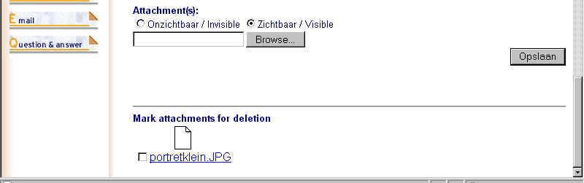
Near the bottom of the page you see the Browse button where you can grasp files from your local hard disc - wherever in the world that may be on that moment - and attach these files, not just the links! These files will be stored on the server, together with this page. (You can leave them also temporarily invisible for students, for example "The good answer" file.) Earlier attached files can the teacher rip off with a simple checkmark for the filename: this way you have for each topic an elegant resources "box".
Now Back to the Roster screen: Press the button Roster in the left menu bar. We call it a Roster to stress the meaning of it as overview for a student's to-do-list in a course. (Oxford American Dictionary)
If you look at this Scheme, you can see some regularity in it. With exception of he timeline column
(Date and Location), each line is a combination of three topic-boxes with an extra small box right next to each of these boxes. If there is an icon in these extra boxes, it means for students: "I have to deliver homework for the topic left of this box". For the teacher it is the place to view & collect the homework of that topic box.

If you press as a teacher one of these icons that homework box opens up:
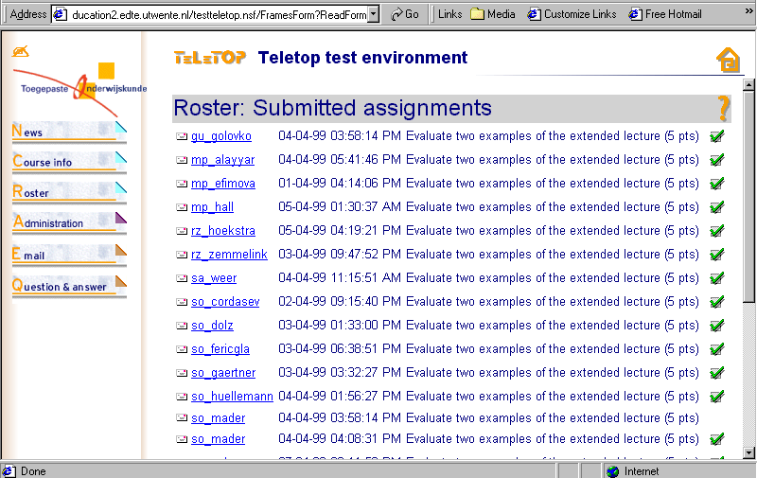

As a teacher you can open each student's answer fill in form view, by clicking on a student name.
(Take again a look at the student homework delivery form, earlier in this text.) This form will show up with the answers of that student. Read it, fill in the now visible feedback box and/or attach a feedback standard-answer-file from your local disc with the same easy Browse & Attach procedure.
As a teacher you can - all by yourself - change the names above the columns in the Roster scheme, depending of your needs, like for example in the next screen of another course. You can also see in a glance that it uses a different homework schedule:

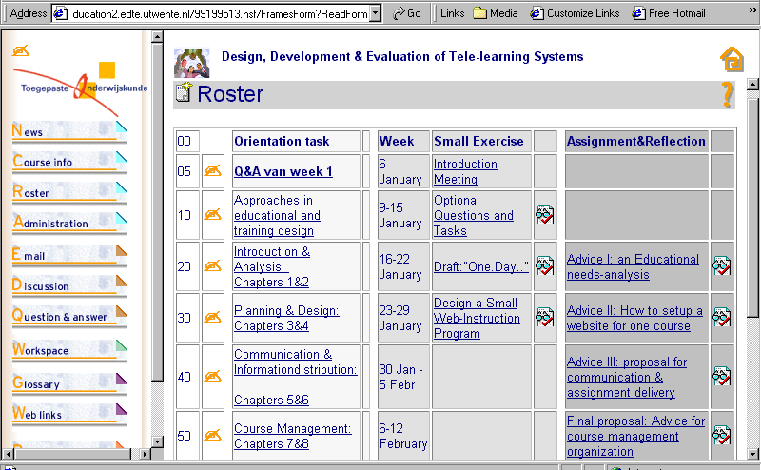

On this point starts your own creativity:
- collect topics for your course, think of assignments in your expertise field
- make a draft and fill in the Roster, row by row, and if you like: reshuffle the rows.
- you even can bring in a new row - even during a course- by clicking on the notebook icon
- And if you need other collaboration tools for your students - even when already running a course - then click on the writing hand on top of the sidebar and add step by step other functionality to your course environment, just by changing in de drop down boxes the No in a Yes. (Discussion Tool, Question &Answer, Shared Workspaces, Glossary page, an extra Web Links page, Publication Reference Page, Plug in page...)



